**PCSDK setup**

Contents

1. Download PCSDK from website: 1

2. Run file .exe to setup PCSDK on your computer 1

3. Check if the installation work in visual studio 2

# Download PCSDK from website:

* Graphical user interface, application

  Description automatically generatedOpen link: [ABB-Developer Center (robotstudio.com)](https://developercenter.robotstudio.com/)
* Click PC SDK
* Download latest version

# Run file .exe to setup PCSDK on your computer

* Text

  Description automatically generatedRun file Setup.
* Continue through the steps and install the PC SDK.

The following are installed on your PC:

• SDK assemblies and resources

• Application manual PC SDK

• Reference Manual PC SDK

# Check if the installation work in visual studio

* Graphical user interface

  Description automatically generatedOpen Visual Studio
* Create a new project
* Choose Window Forms App (.NET Framework)

* Choose Name, Location of project and click Next

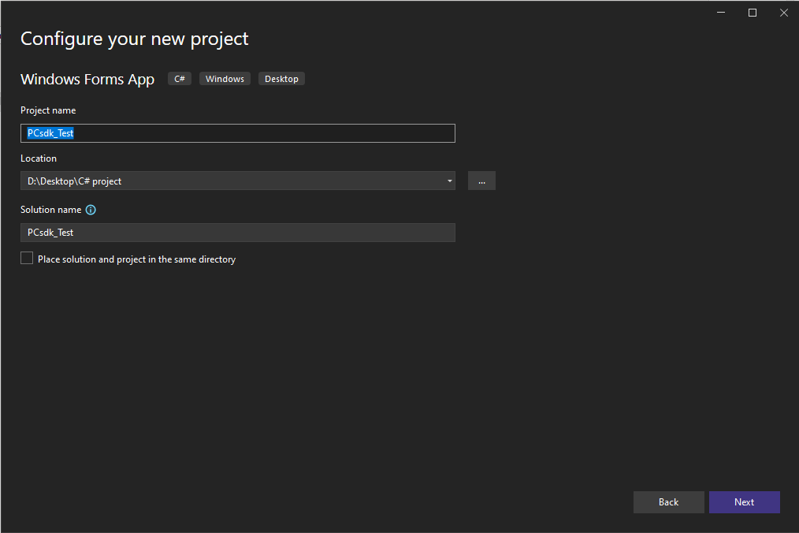

* Create the Form

* Go to Project🡪Add Reference

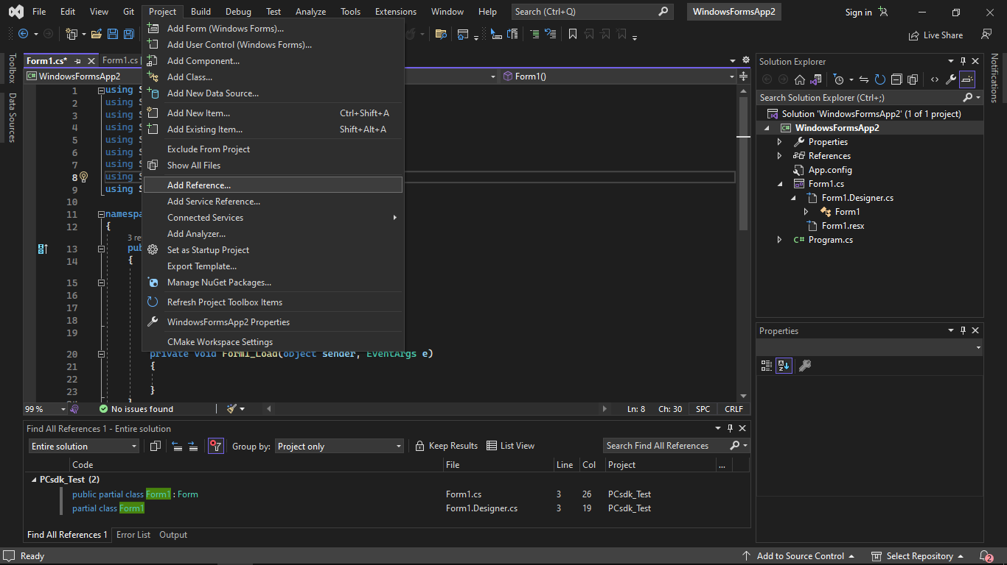

* Browse to location C:\Program Files (x86)\ABB\SDK\PCSDK 2022\ and add 3 files .dll to the project:

* Check all the box in front of 3 .dll files and click OK

* Add line “using ABB.Robotics.Controllers;”, if there is no error then the installation is complete and we are ready to use pcsdk for coding.

